**Talend Job workflow documentation**

**Workflow run**

* Workflow to load data into staging tables

MySQL - stg_food_inspections

Azure SQL Server - stg_azure_food_inspections

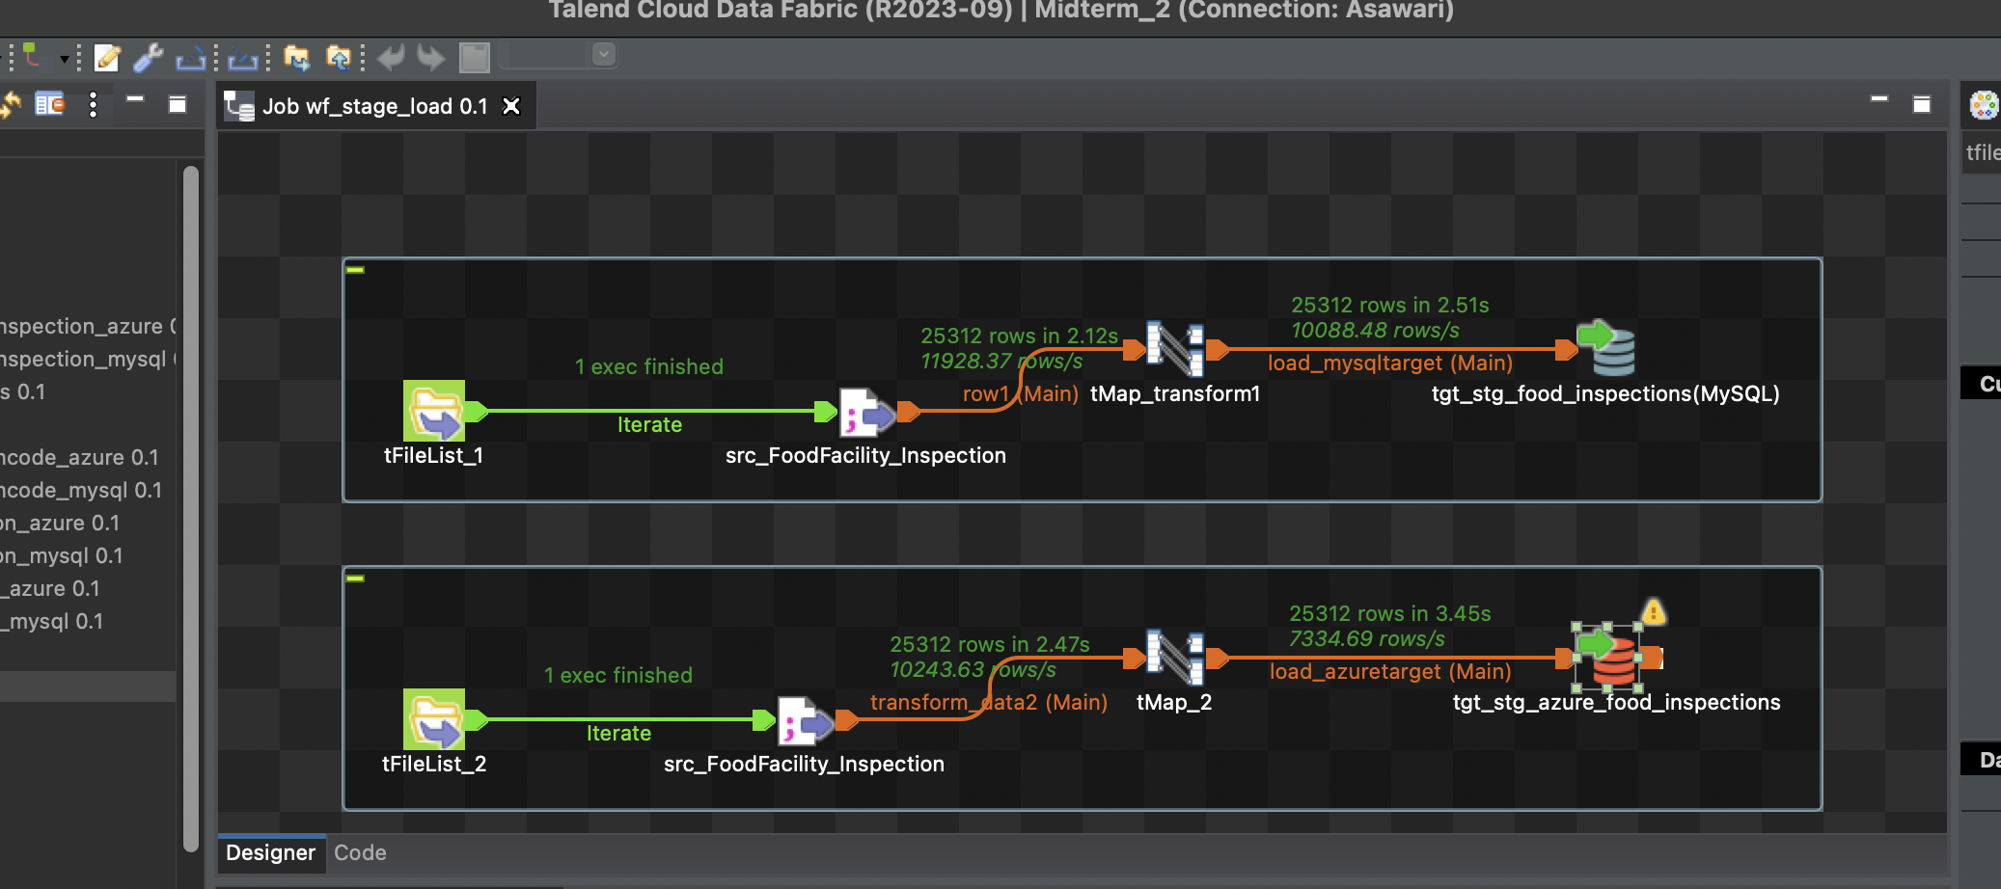

* Loading data to Dim_Business

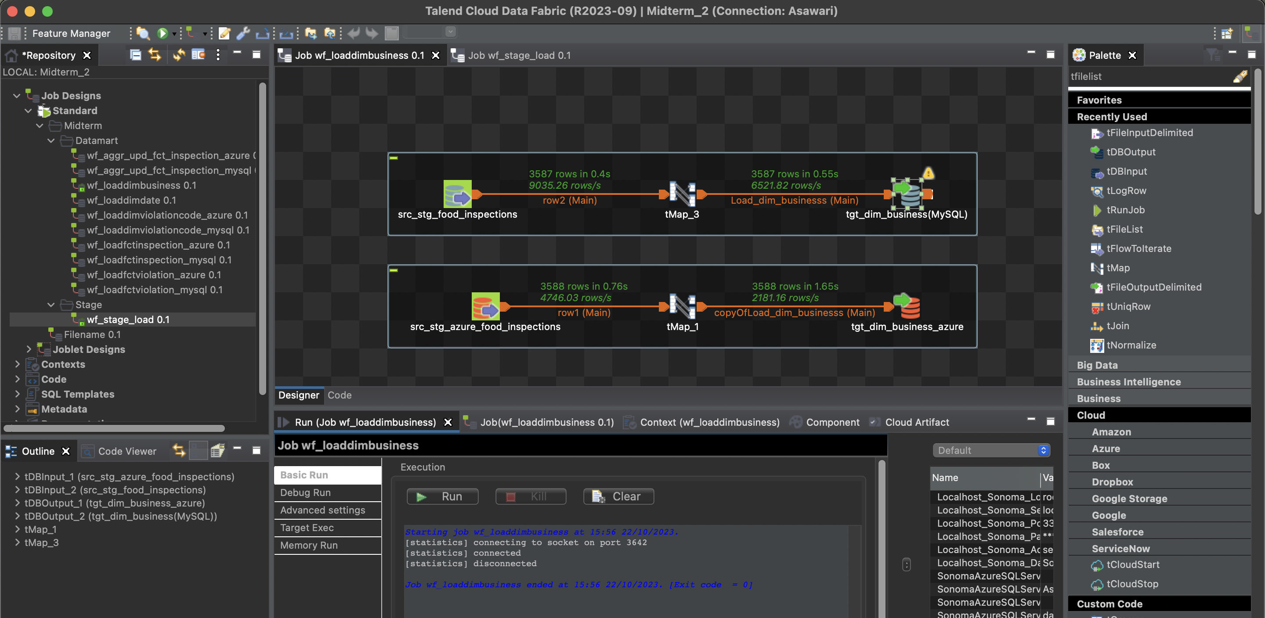

* Loading data to Dim_Date

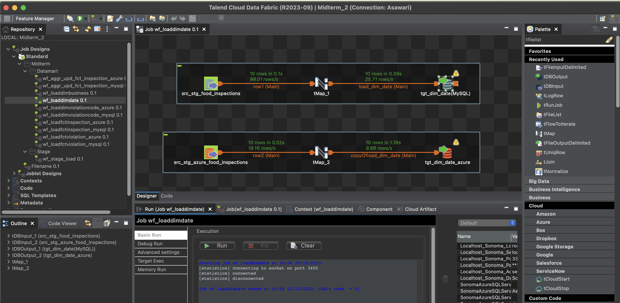

* Loading data to Dim_ViolationCodes

MySQL:

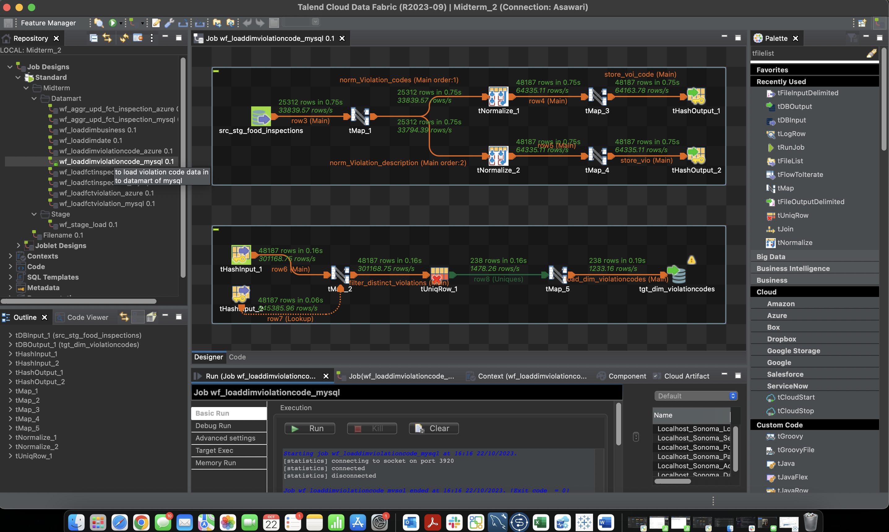

Azure Sql Server:

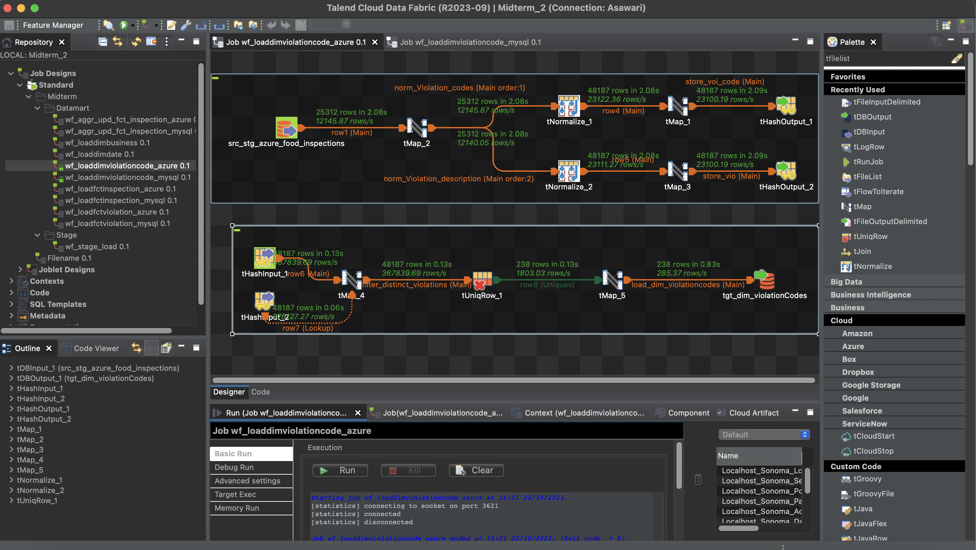

* Loading data to Fct_Inspection

MySQL:

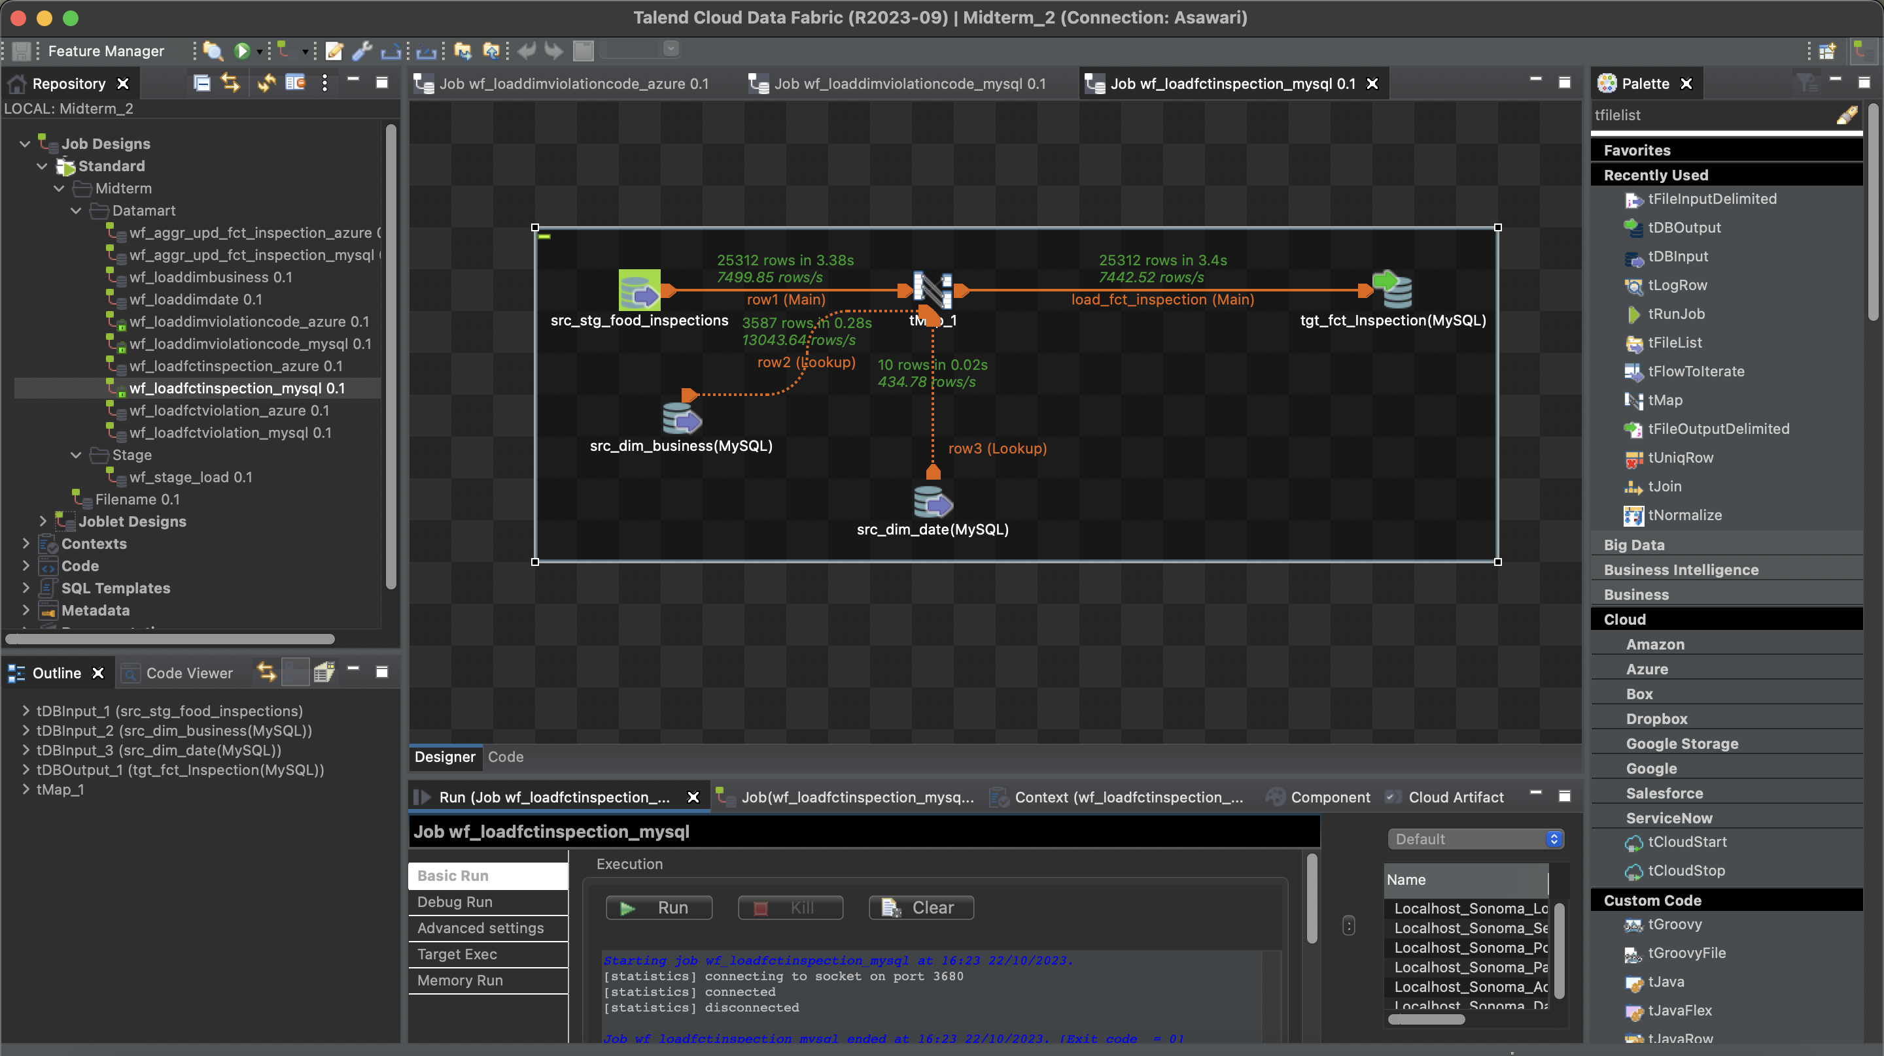

Azure SQL Server:

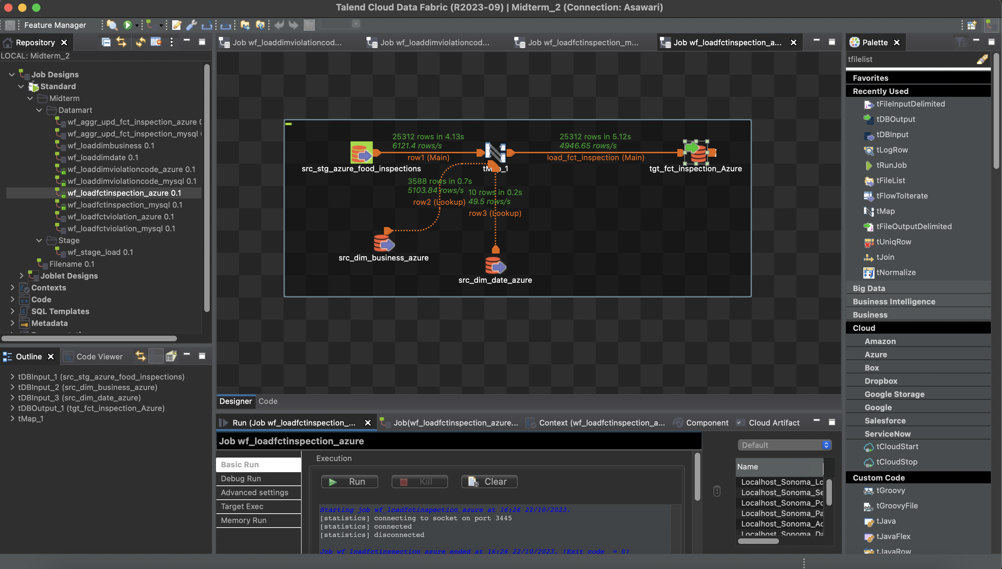

* Loading data to Fct_Violation

MySQL:

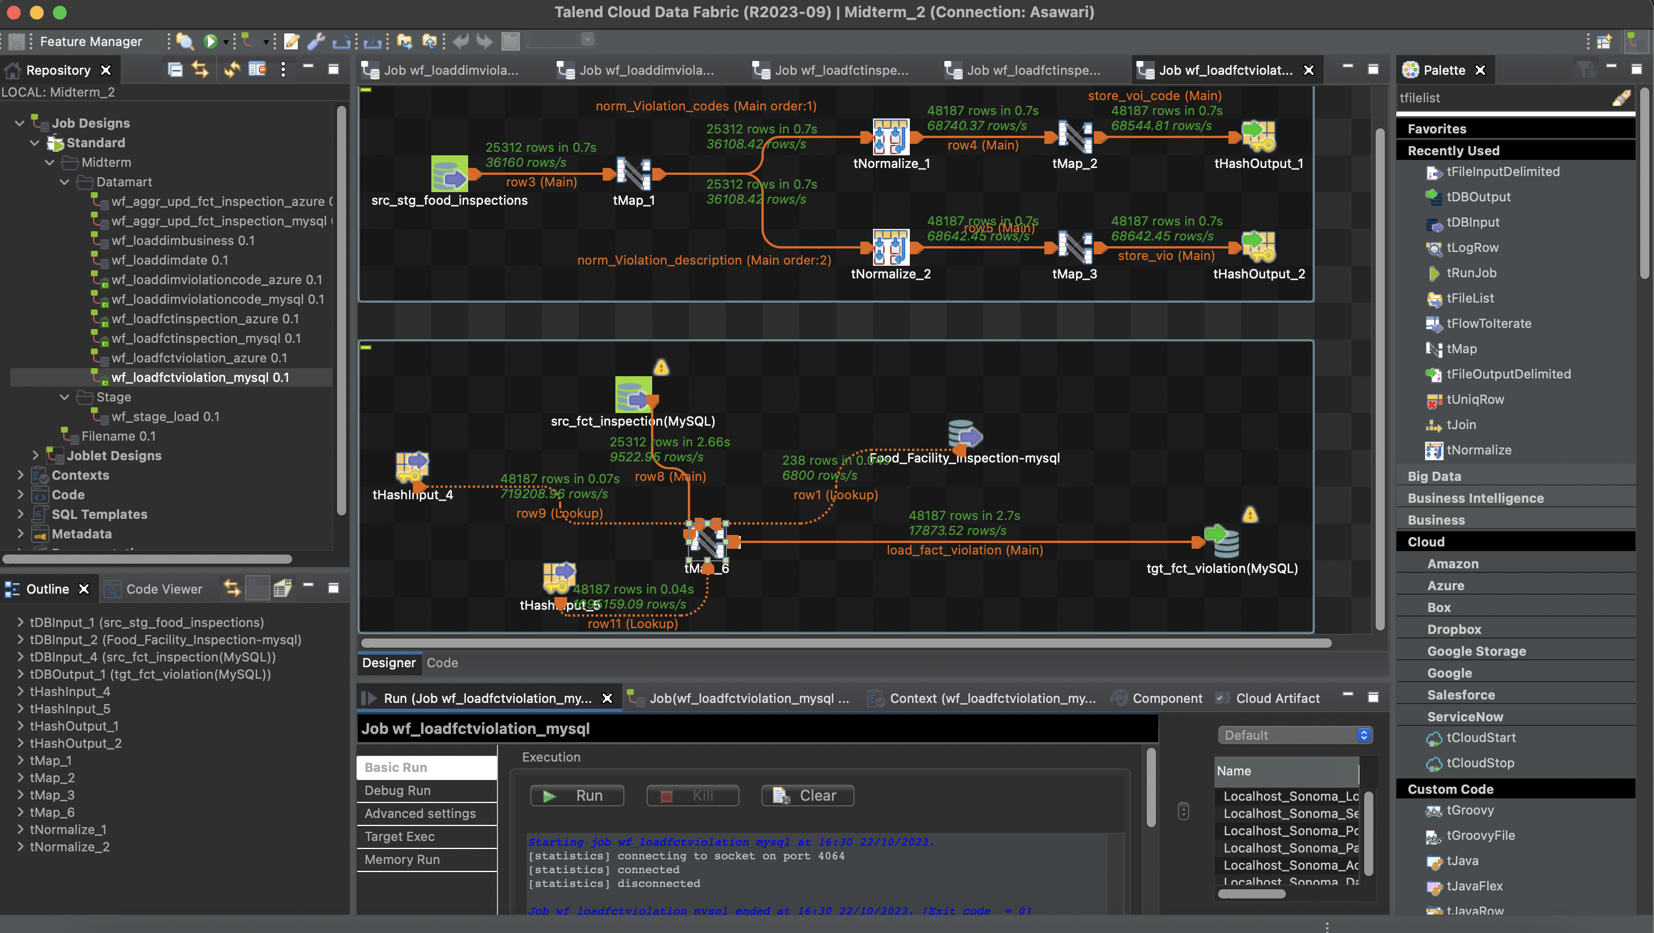

Azure SQL server:

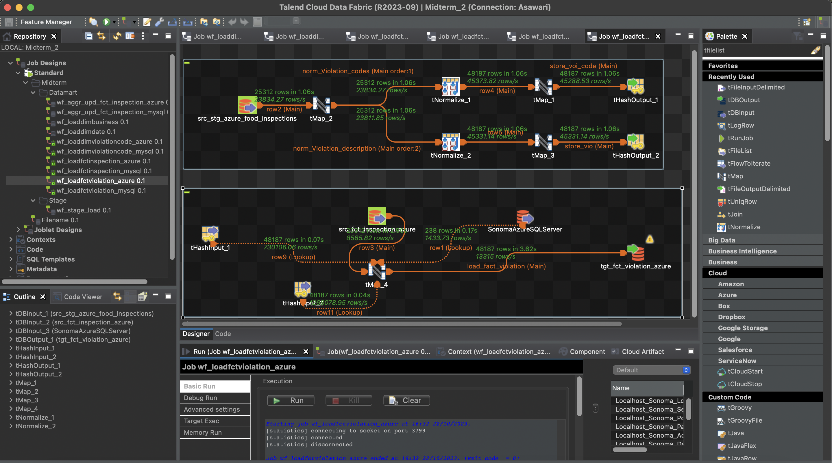

* Loading InspectionResult and aggregated violationScore into Fct_Inspection

MySQL:

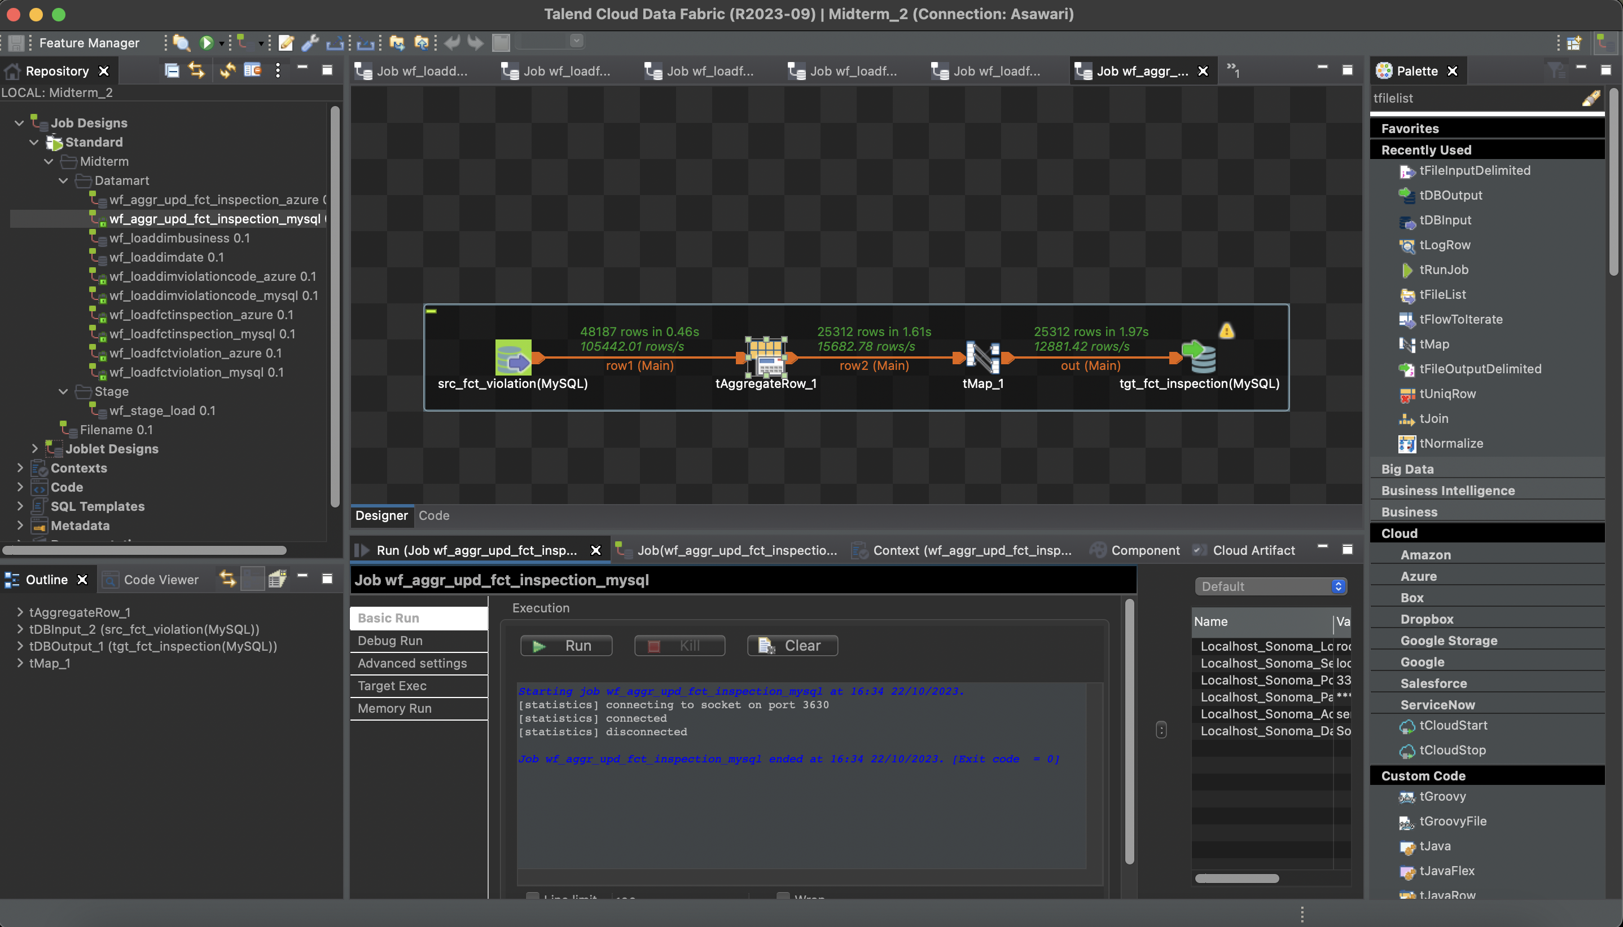

Azure SQL Server:

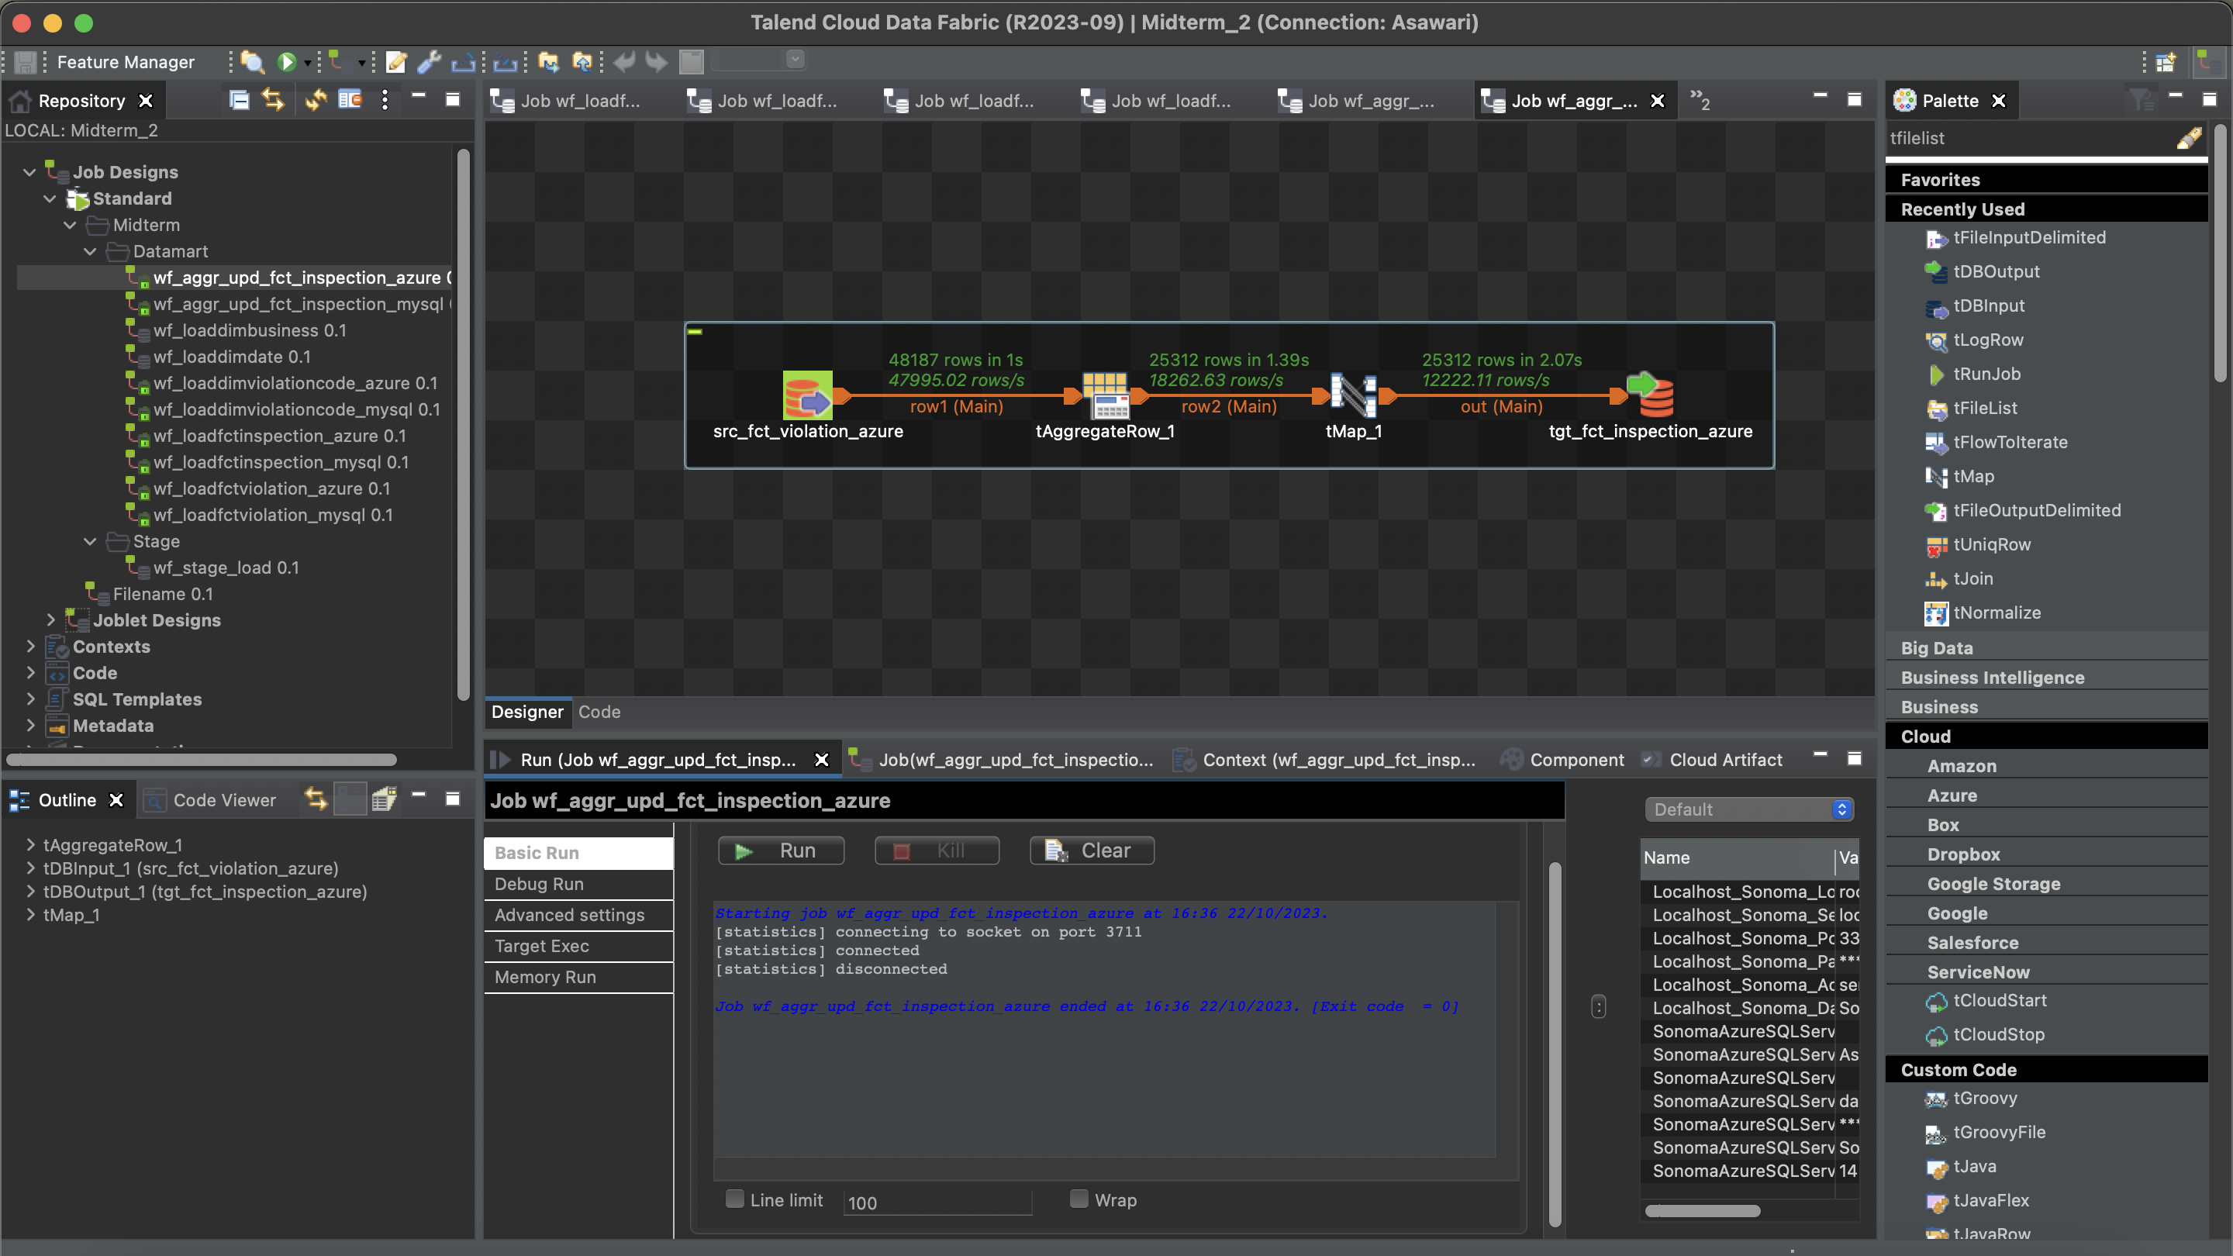

**Total count of each table**

* Staging table data

MySQL:

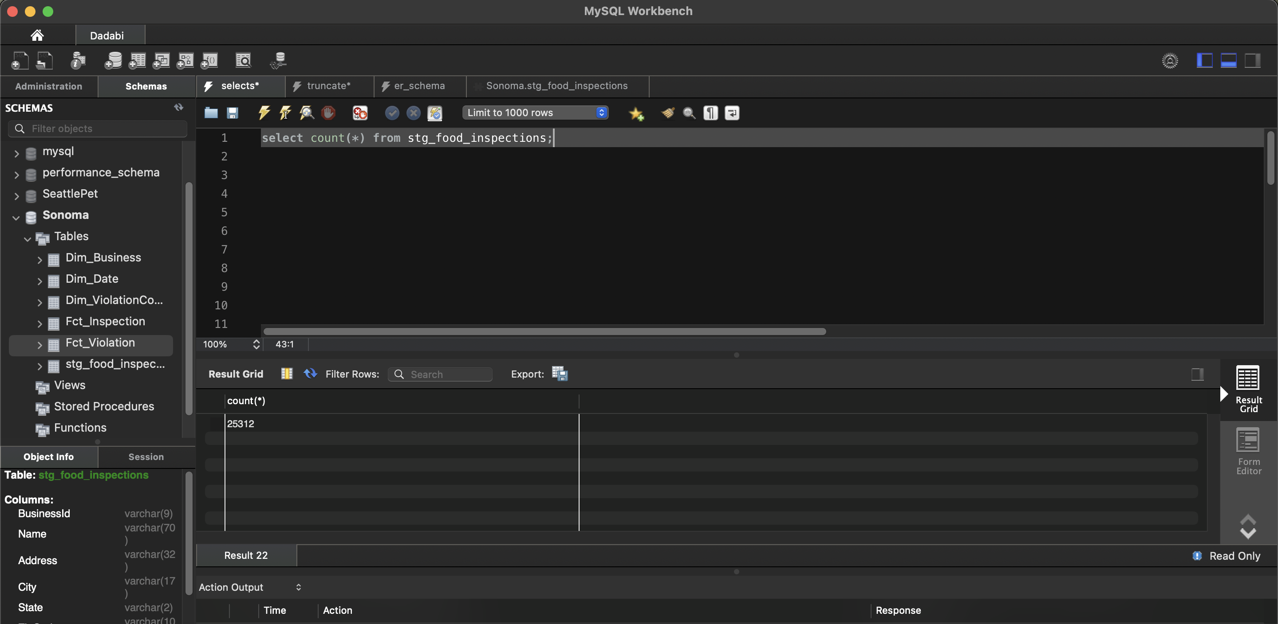

Azure SQL Server:

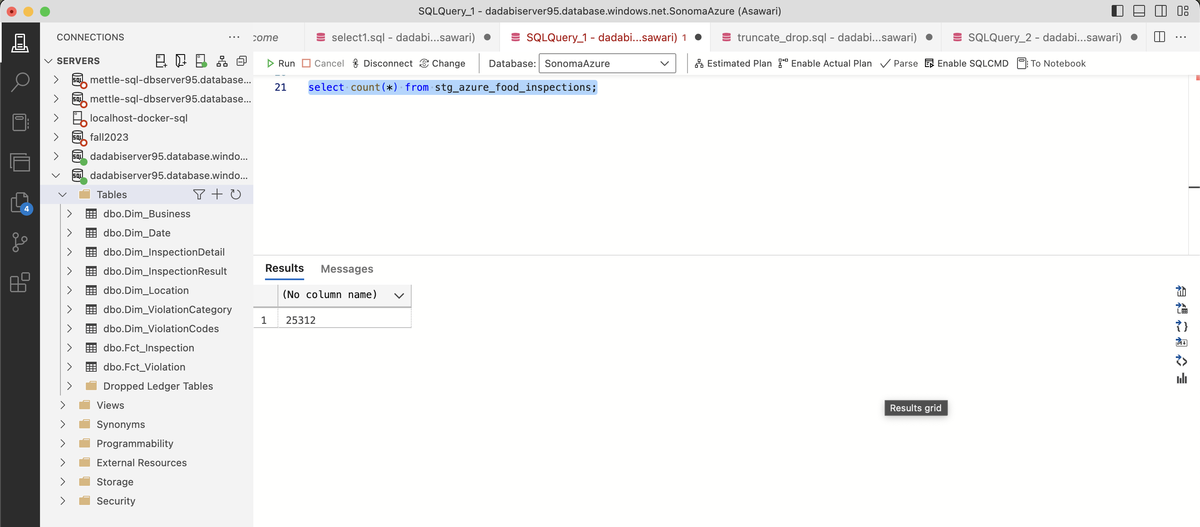

* Dim_Business

MySQL:

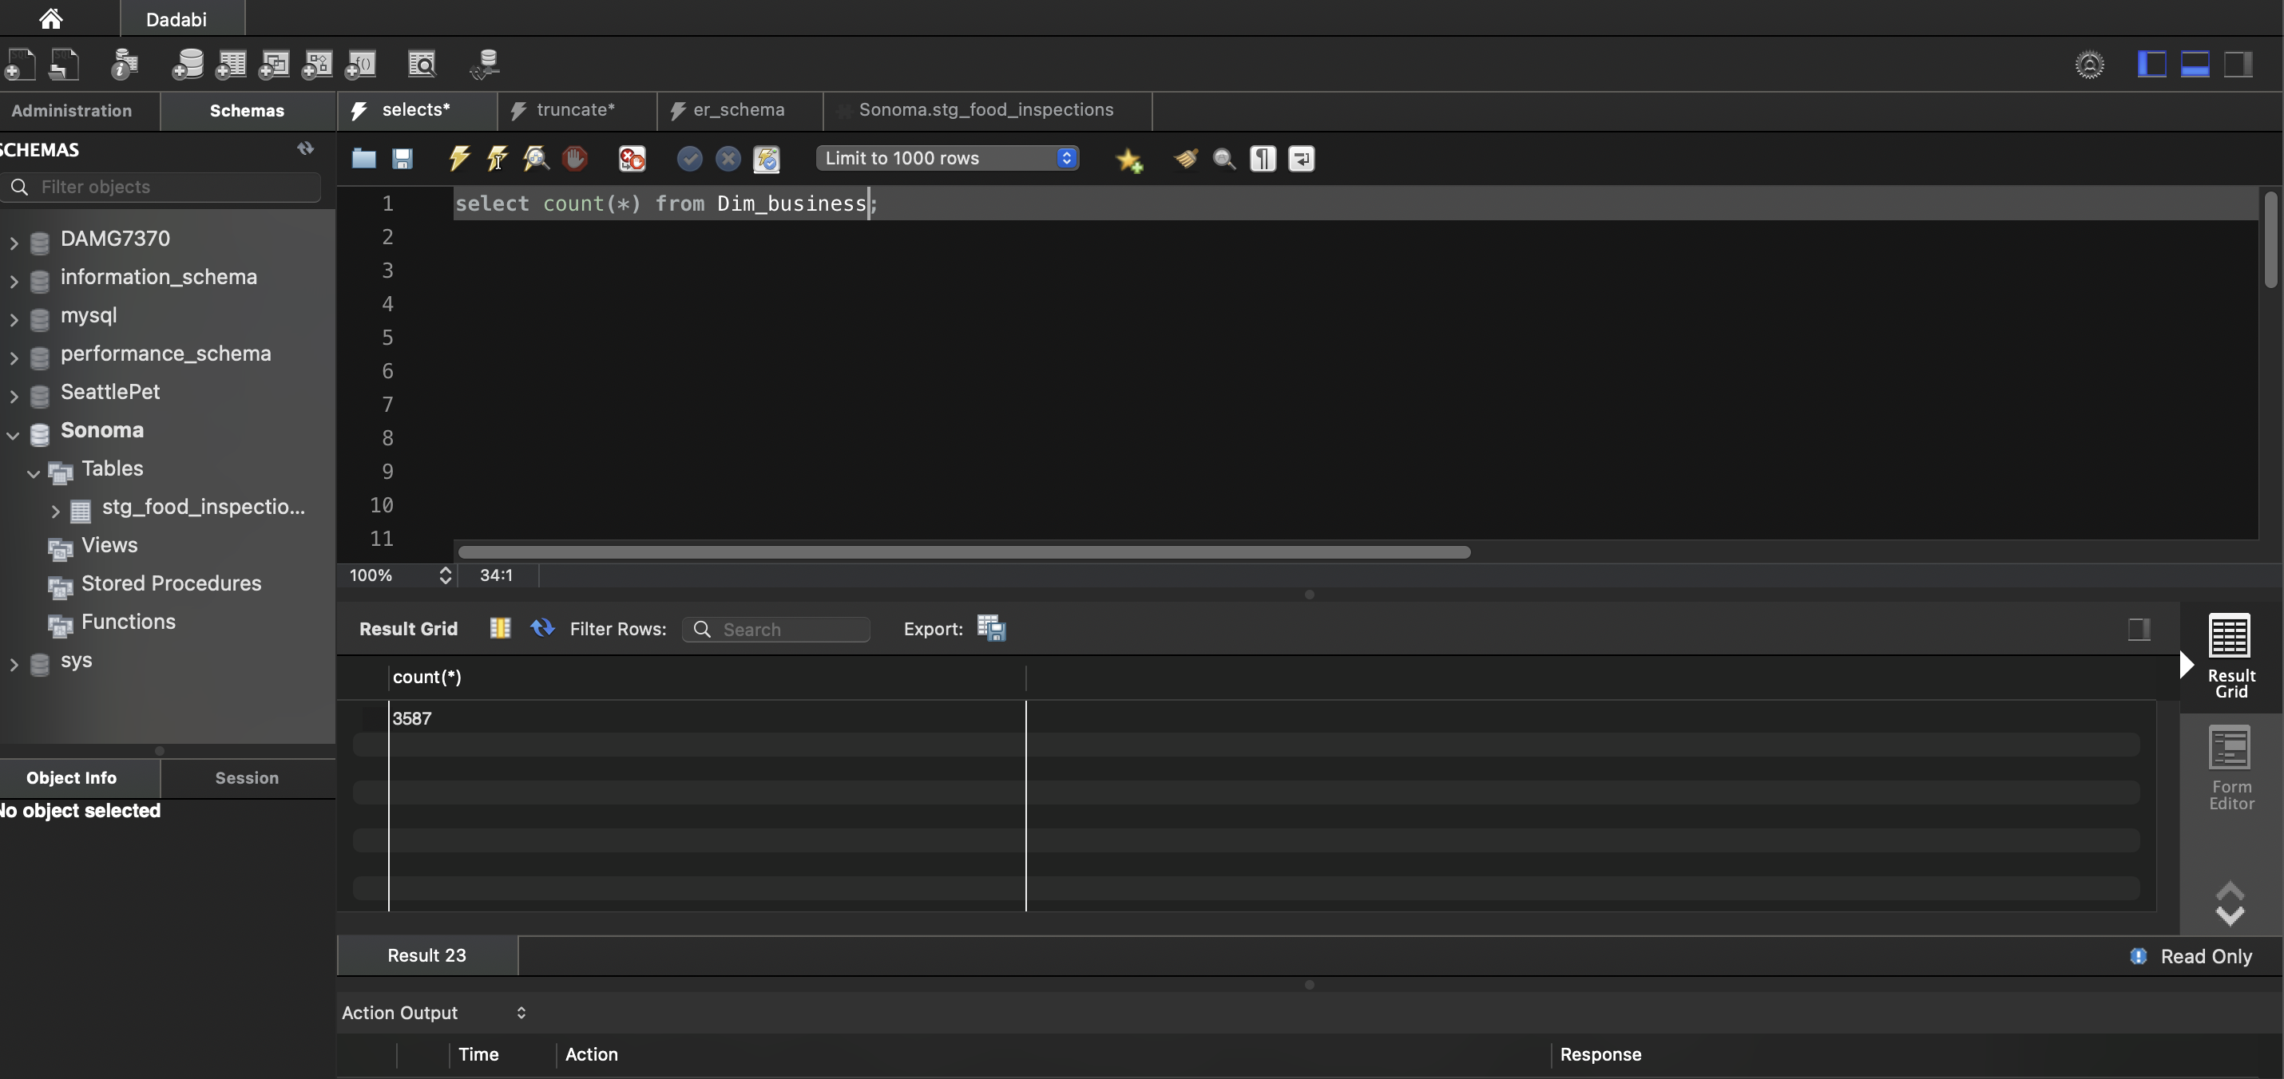

Azure SQL Server:

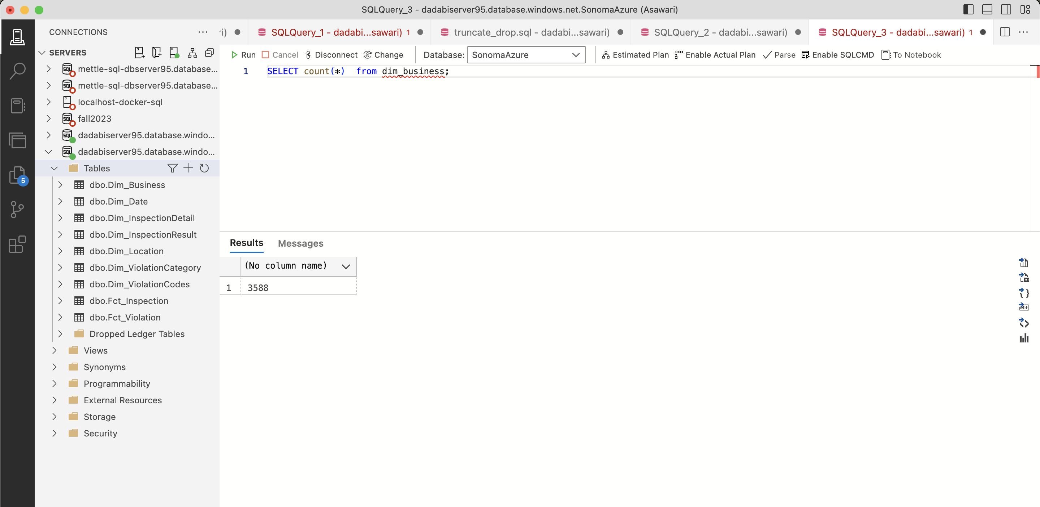

* Dim_Date

MySQL:

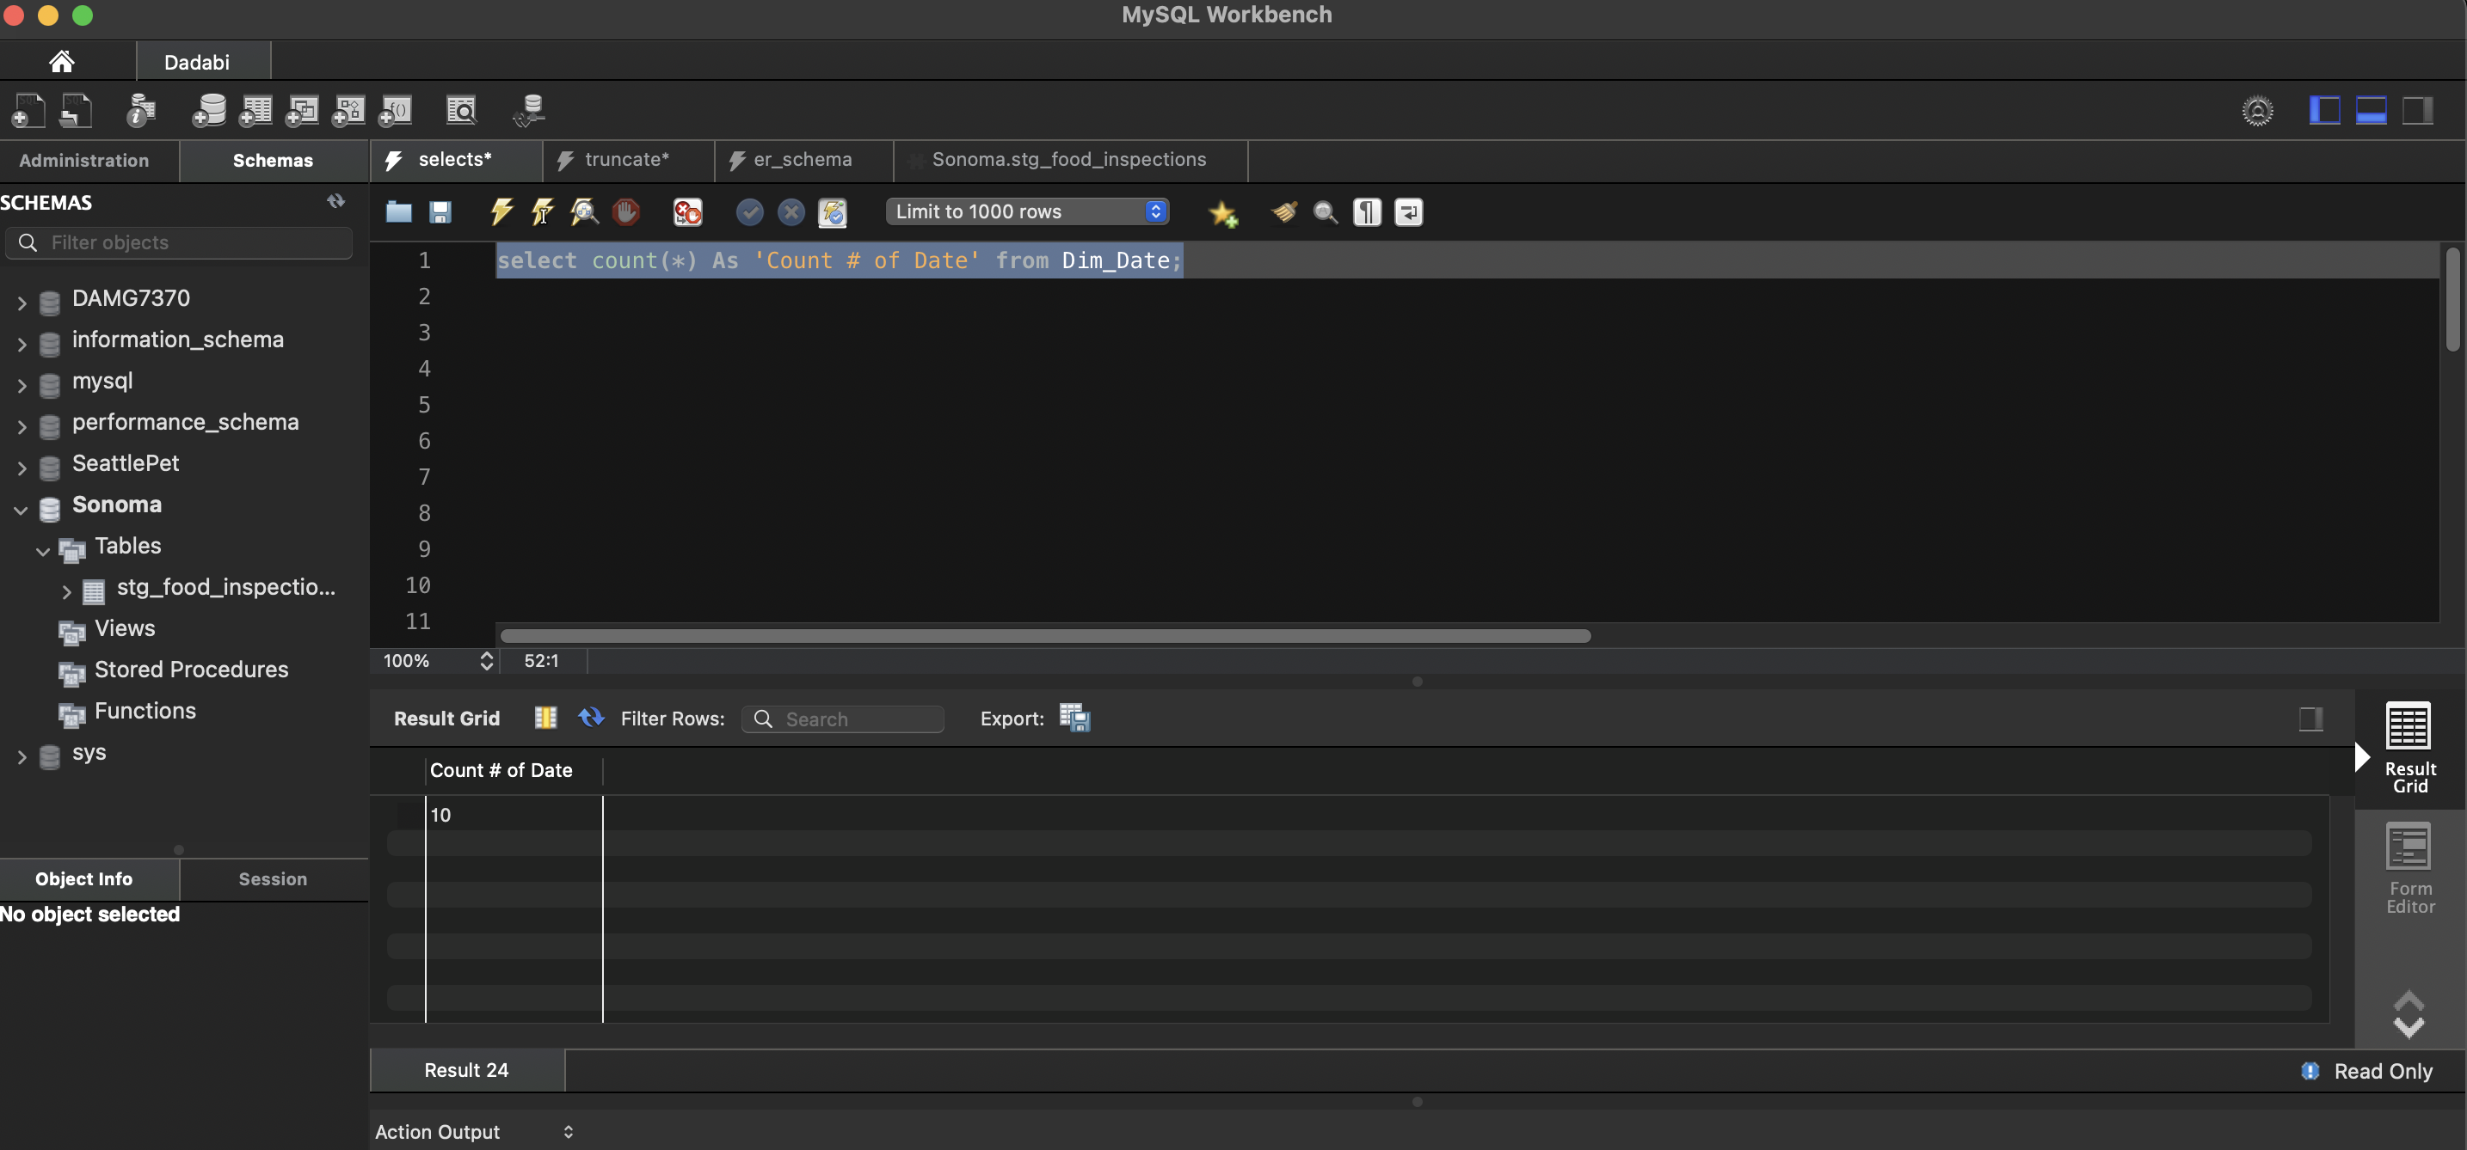

Azure SQL Server:

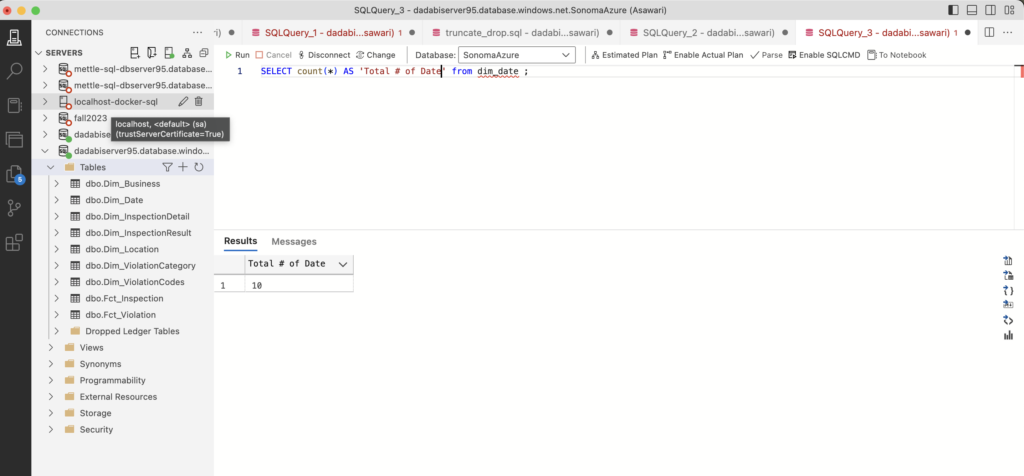

* Dim_ViolationCodes

MySQL:

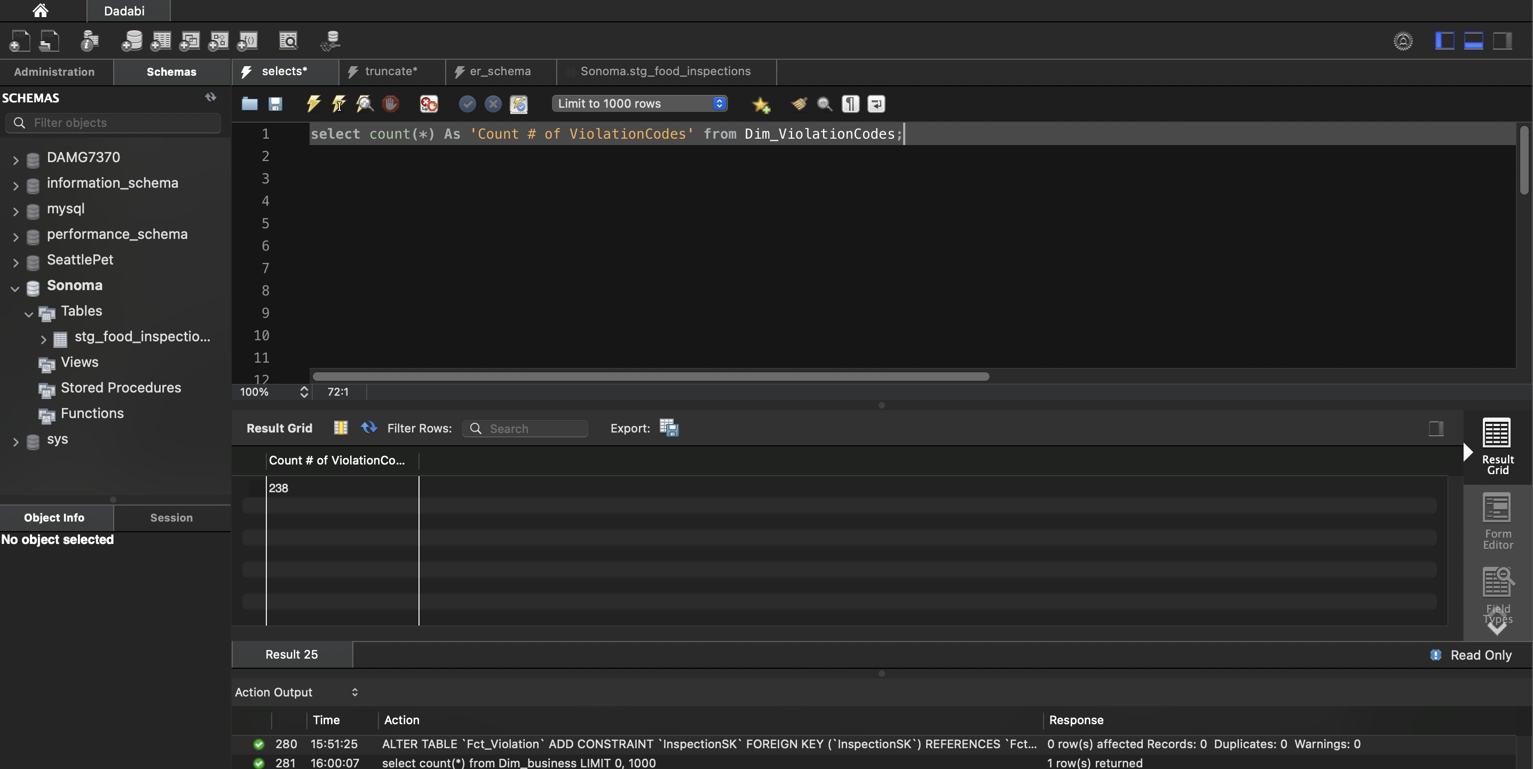

Azure SQL Server:

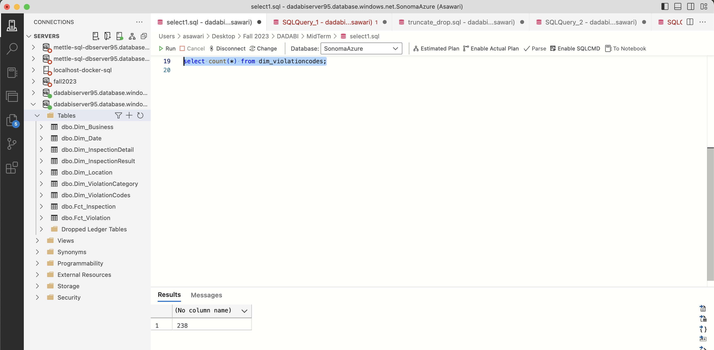

* Fct_Inpsection

MySQL:

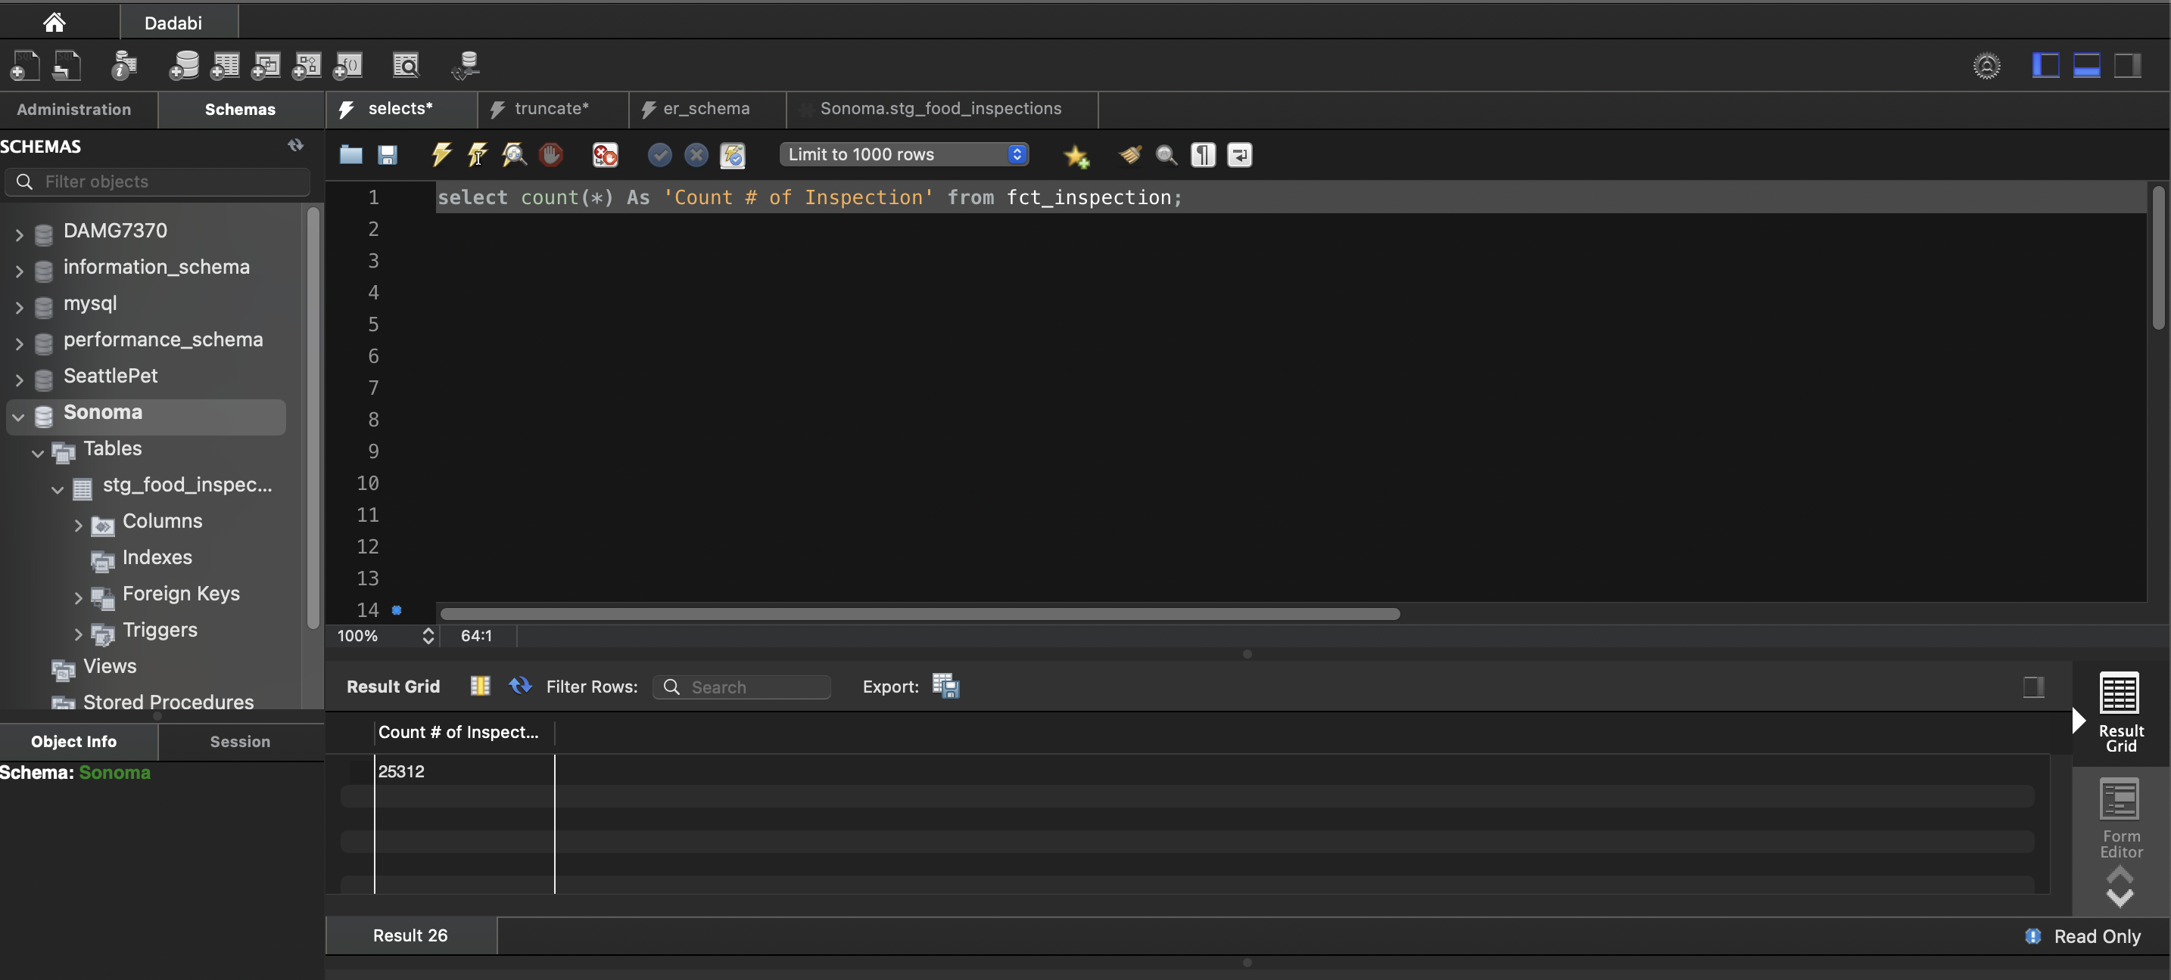

Azure SQL Server:

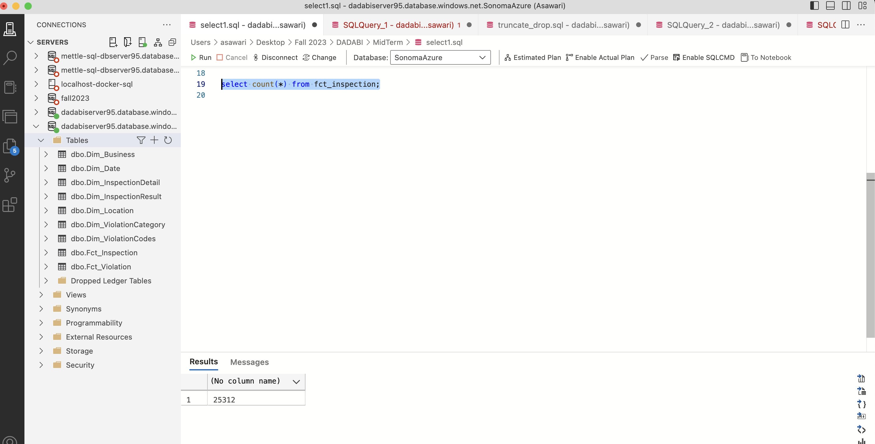

* Fct_Violation

MySQL:

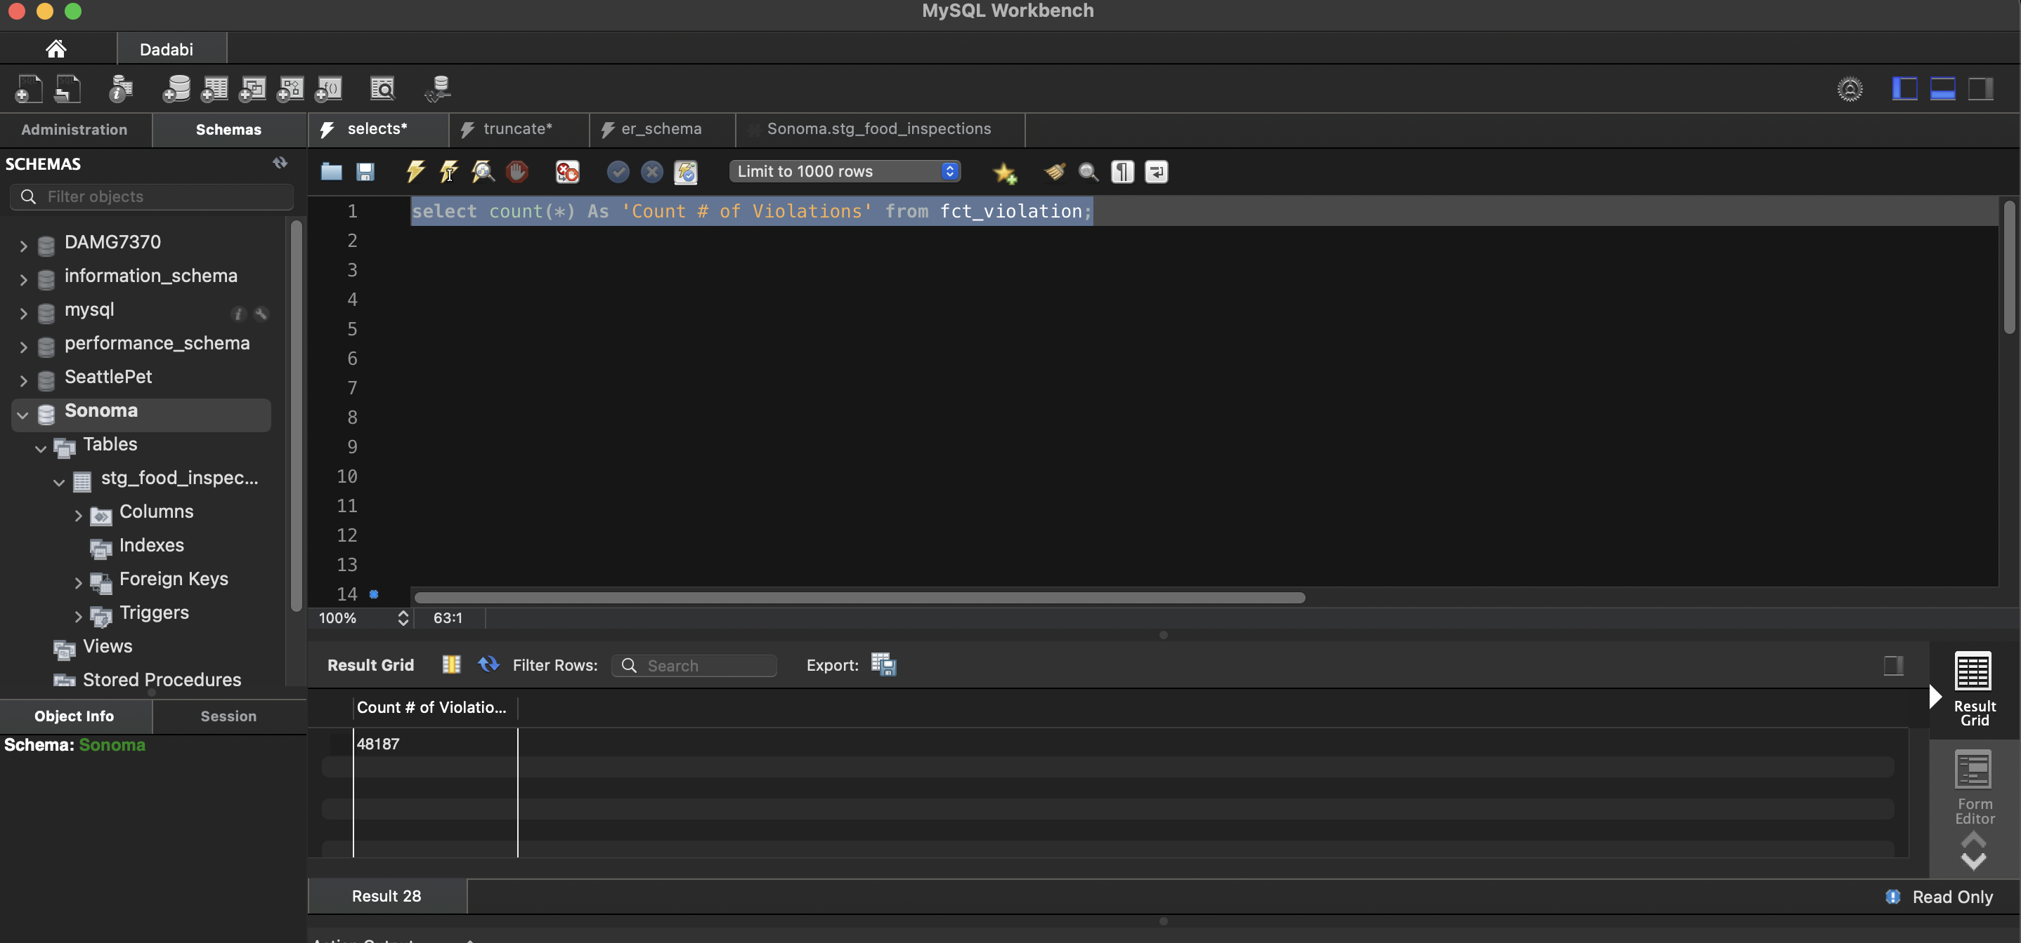

Azure SQL Server:

